**New Hampshire SSB Qualities**



**Empowered**

**Stand up for what you feel is right.**

**Know when you need help.**

**Believe in yourself.**

**Resilient**



**Challenge yourself.**

**Learn from mistakes.**

**Forgive yourself and others.**

**Responsible**

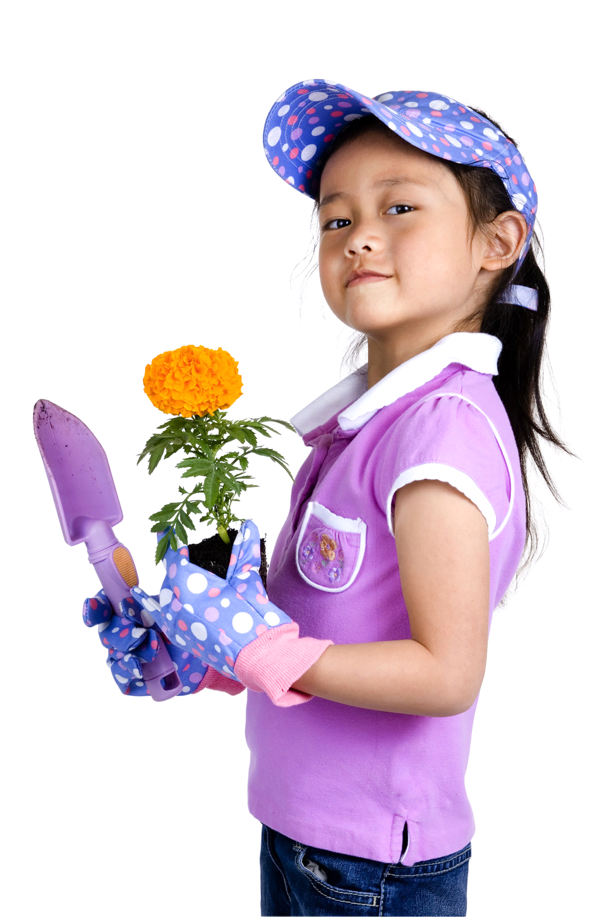

**Come ready to share, learn, and participate.**

**Organize and take care of the space around you.**

**Set goals and work hard to achieve them.**

**Explorers**



**Be curious and ask questions.**

**Use your imagination.**

**Be independent and find answers to problems.**



**Accept each other for who we are.**

**Listen and respect each other’s ideas.**

**Open**

**n**